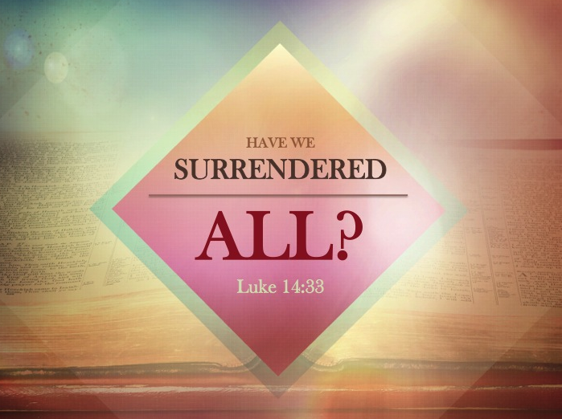

Listening Guide
Lesson Text: Luke 14:25-35

- We live in a culture that loves to approach life as a bunch of check boxes. Sometimes this concept has not been foreign to the church.
- We can be guilty of approaching worship as a check box item or a “going through the motions mentality”.
  - We can be outwardly doing all the right things, but inwardly experiencing no change.
- LARGE CROWDS were following Jesus. He almost seems to doubt their ability to fully understand what it means to be his disciple. Jesus enlightens them and speaks in a way that is a radically different way of living.
- Disciples and Christians are referred to as one and the same (Acts 11:26).
  - To be a disciple means to submit oneself to the teaching of that leader.
- ARE WE WILLING TO COME TO JESUS ON HIS TERMS?
- Hate father, mother, wife, children, brothers, sisters, yes even our own lives. If not, such a person cannot be a disciple of Jesus.
  - Love for Jesus is supreme. (Matthew 22:36)
  - Begrudging obedience does not exist in the life of a disciple of Christ.
- If we do not carry our crosses and follow Him, we cannot be His disciple.
  - The cross is a symbol of death. He call’s his disciples of die to self and live for Him.
  - Galatians 2:20
- Estimate the cost or consider whether you are able before you even decide to be His disciple. Jesus is begging you.
  - Don’t build unless you can finish
  - Baptism is only the beginning, not the end
  - Don’t go into war unless you are going to fight.
- Jesus requires His disciples to give up everything or you cannot be His disciple.
  - Matthew 19:16-24
  - Who are the Rich?
    - Over three billion people live on less than $2.50 a day
    - 22,000 children die every day due to poverty.
    - 1.1 billion people in developing countries have inadequate access to water and 2.6 billion lack basic sanitation.
    - Even if you’re stuck in the bottom 5% of the US income distribution your standard of living is about equal to that of the top 5% of Indians.
  - Hebrews 10:32-34
  - Hebrews 11:24-26
- Have you truly surrendered it All?
  - Have you come to Jesus on His terms or have you been living your Christian life on your terms?
  - 1 John 2:28 – Be confident and unashamed at His coming

